**HOLIDAY PACKAGE TERM III, 2023 MIDDLE CLASS**

**GENERAL INSTRUCTIONS:**

**1. This Holiday package is composed of all subjects taught in middle class.**

**2. Each subject contains three covered topics of last term.**

**3. All work in each subject shall be marked out of 100mks.**

**4. Parents can assist their children in the project work.**

**5. Parents should ensure that children attempt all questions.**

**6. Diagrams must be drawn in pencils.**

**7. Parents should ensure that the Holiday package comes back when it’s clean.**

**8. Good handwriting will earn you an extra mark.**

**9. Parents should guide the pupils and not to write for them.**

**10. Holiday package shall be submitted in on the first day of Term one, 2024. Any work which will come after the first day shall not be received.**

**11. Holiday package will be counted in the continuous assessment.**

**12. Parents/children who meet any challenges should contact the school for assistance.**

**Name: _____________________________________________**

**Class: ______________________________________________**

**School: ____________________________________________**

**LEARNING AREA 4 - NUMBERS**

**1. Match the same number words and write the figure.**

zero ten ________

one nine _______

two eight _______

three seven ______

four zero _______

five one _______

six two _______

seven three ______

eight four _______

nine five ___5___

ten six ________

**2. Write the number name.**

0 ___________ 5 __________

I ___________ 6 ___________

3 ___________ 8 ___________

2 ___________ ___________

___________ I0 ___________

nine, eight, zero, three, one, seven,

five, two, six, four, ten

**3. Write the next number.**

0 _______ _______

2 _______ 7 _______

3 _______ 8 ________

I _______ 6________

5 _______ ________

**4. Add the pictures and write the figure.**

+ = _______



+ = ________

+ = _______

+ = ________

+ = _______

+ = ________

+ = ________

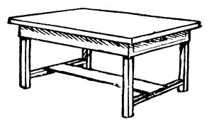 + = ______

**5. Count and write correctly.**

2 + 2 = ________

6 + 3 = ________

+ 3 = ________

+ = ________

2 + = ________

+ 5 = ________

5 + 5 = ________

+ = _________

**6. Write numbers 0 – 20.**

0 _____ _____ _____ ______ _____ _____ _____ _____ ____ ____ ____ ____ _____ _____ _____ ____ ____ _____ ____ ____

**7. Count and match correctly.**

3

I0

5



7

6

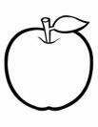 8

**8. Count the beads and write the number.**

**9. Fill in the middle number.**

0 _______2 2 _______

3 ______ 5 ______ 6

5 ______ 7 6 ______ 8

7 ______ 8 ______ I0

______ I I

**10. Fill in the missing number.**

20 _____ 22 _____ ______ 25

26 _____ ______ 29 30

**11. Count and write.**

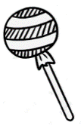 = _________

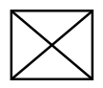 = ________

 = __________

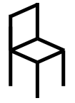 = __________

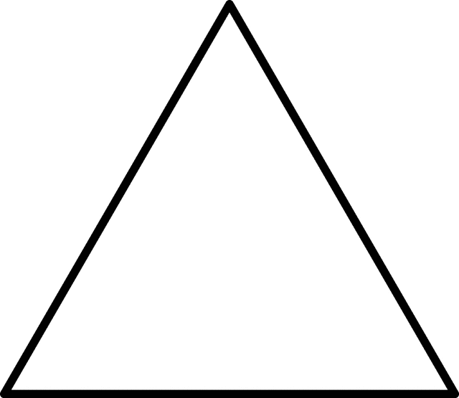       = _________

**12. Name the shapes.**

 ________ ________ ________

________ ________ ________

circle, triangle, square, oval, rectangle,

star, zigzag

**13. Count and circle the correct number.**

= 3 7 5

= 2 3

= 6

= 5 2

= 7 5

= 2 3 8

= 3 7 5

**14. Draw bead for the number.**

**7 3 6 2 9 I0**

**15. Match the same and write the number**

eight seven _______

six four ________

nine five _________

ten six _________

three eight ________

seven nine ________

five three ________

four ten ________

**LEARNING AREA 2 - READING**

**1. Draw a picture for the given sound.**

g _________ l __________

p ___________ c ____________

m ___________ d ___________

**2. Circle the correct word.**

pto pot

egg geg

sun snu

irgl girl

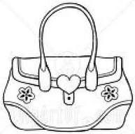

bag bga

**3. Draw a picture for the given syllable.**

mu __________ ca___________

ba ___________ gu __________

po ___________ ha __________

ti _____________

**4. Underline words of sound ‘ee’**.

table green drum

three ball cat

bag sun sheep

doll tree egg

sweep girl stone

**5. Match the same words and draw.**

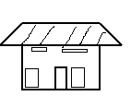

P.1

ppo

P.2

P.4

book school ________

spoon door __________

stool moon _________

broom stool _________

moon spoon _________

door book _________

school broom ________

**6. Write the words correctly.**

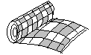

mta pto

_________ _________

 gba blla

_________ _________

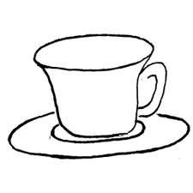

nti cpu

_________ _________

cra yob

__________ _________

**7. Fill in the missing sound ‘oo’.**

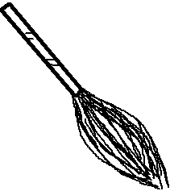

br___ ___m st___ ___l

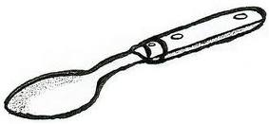

m ___ ___n sp___ ___ n

d ___ ___r

**8. Read and draw pictures.**

It is a big tin _____________

Kim has a zip ____________

This is a pig ______________

It is a pin _______________

**9. Match to the correct prepositions.**

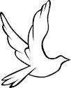

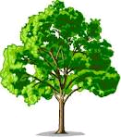 on

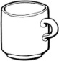 over

under

near

in

**10. Find the number for the picture.**

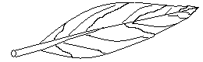

**8 I 7 9**

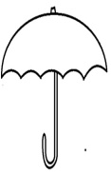

**I0 6 2 3 5**

dress basket

moon stick

snake bottle

umbrella house

leaf star

**11. Complete the sentences.**

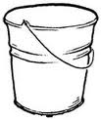

This is a _______________



I can see a ___________

It is a ________________

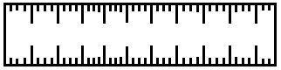 It is a ________________



Here is a _____________



 Here is a _______________

This is a ______________

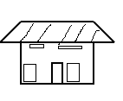

This is a ______________



It is a __________________

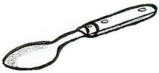

It is a __________________

**12. Name the pictures.**

** ________ ________ ________**

**________ ________ ________**



 **_________ ________ ________**

**________ ________ ________**



**________ ________** ________

**13. Read and draw pictures.**

It is a pencil. __________________

It is an umbrella. ________________

This is a comb. __________________

It is a stick. _______________________

This is a basket. _______________

I can see a window. _____________

**14.** **Read and fill in.**



A _______ and a ________



A _______ and a _______



A _______ and a _______

A ________ and a ________

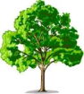

A _______ and a ________



A _______ and a ________

 A _______ and a ________

**15. Draw these prepositions.**

under __________ in ___________

over __________ on __________

**16. Copy and write the letters.**

|  |  |  |  |  |  |  |  |  |  |
| --- | --- | --- | --- | --- | --- | --- | --- | --- | --- |
| A | B | C | D | E | F | G | H | I | J |
|  |  |  |  |  |  |  |  |  |  |
| K | L | M | N | O | P | Q | R | S | T |
|  |  |  |  |  |  |  |  |  |  |
| U | V | W | X | Y | Z |
|  |  |  |  |  |  |

**17. Write the next letter.**

a b ________ d e ________

g h i ________ k l m _______

**18. Circle capital letters only.**

B

a

A C

c

d D

f F

H r T G

R Y

**19. Change words from capital to small.**

MUG __________ BAG ____________

AXE __________ BALL ____________

HOE ___________ CUP ____________

KITE ___________ FISH _____________

GUN ____________ BOY ____________

**20. Match the same letters and write.**

h q ______

i p ______

j o ______

k n ______

l m ______

n k ______

o j _______

p i _______

q h ______

**21. Match letter to its word.**

g sun

h rat

c pot

b axe

m moon

a ball

p cat

r hat

s girl

**22. Make sentnces using:- It is _______**

_________________________________

 _______________________________

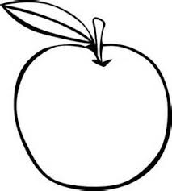 _______________________________

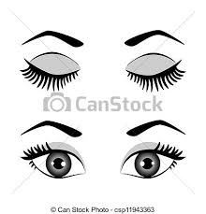 ______________________________

**23. Use an or a**

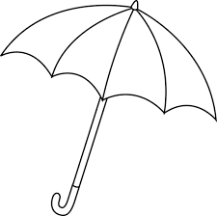 ____ umbrella ____ ball

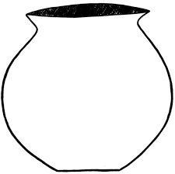 ____ pot  ____ orange

**24. Cross out the word for the picture.**

 axe arrow apple

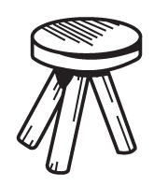 stool school spoon

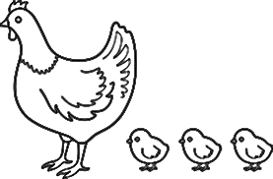 hut hen hat

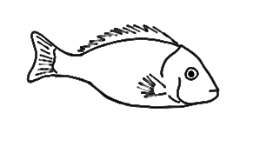 fish fan flower

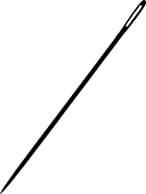 needle net nail

**GENERAL KNOWLEDGE**

**1. Name these domestic animals.**

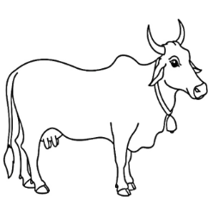 __________ 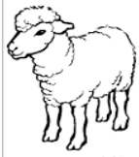 _________

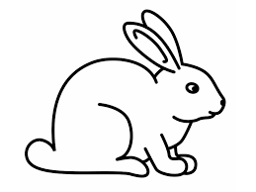 _________ 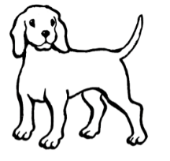 _________

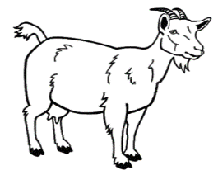 __________

( dog, sheep, rabbit, goat, cow)

**2. Draw these dangerous object.**

|  |  |  |  |
| --- | --- | --- | --- |
| needle | razorblade | knife | nail |
|  |  |  |  |
| safety pin | broken bottle | pin |
|  |  |  |

**3. Match the sources of light to their words.**

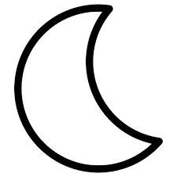fire

 candle

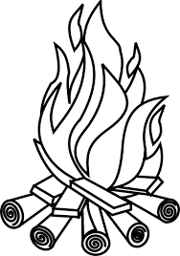 sun

 bulb

 moon

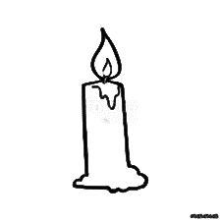 star

**4. Draw a big aeroplane.**

|  |
| --- |
|  |

**5. Read and draw.**

|  |  |  |  |
| --- | --- | --- | --- |
| baby | sister | father | mother |
|  |  |  |  |
| brother |
|  |

**6. Draw the means of transport.**

|  |  |  |  |
| --- | --- | --- | --- |
| aeroplane | bus | car | lorry |
|  |  |  |  |
| bicycle | train |
|  |  |

**7. Read, match and draw.**

goat sheep __________

rabbit pig _________

cow hen ___________

hen rabbit __________

sheep goat __________

pig cow __________

**8. Name the parts of the head.**

**I**

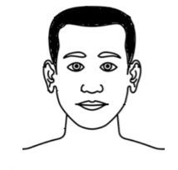

**4**

**2**

**3**

1. _______________
2. _______________
3. _______________
4. _______________

**WRITING**

**I can write the words of letter a**

|  |
| --- |
| **a a a a** |
|  |
|  |

|  |
| --- |
|  |
|  |
|  |

|  |
| --- |
|  |
|  |
|  |

|  |
| --- |
| **apple apple apple** |
|  |
|  |

|  |
| --- |
|  |
|  |
|  |

|  |
| --- |
|  |
|  |
|  |

|  |
| --- |
|  |
|  |
|  |

**Write letter ‘i’**

**I can write the words of letter i**

|  |
| --- |
| **i i i i** |
|  |
|  |

|  |
| --- |
|  |
|  |
|  |

|  |
| --- |
|  |
|  |
|  |

|  |
| --- |
| **ink insect internet** |
|  |
|  |

|  |
| --- |
|  |
|  |
|  |

|  |
| --- |
|  |
|  |
|  |

|  |
| --- |
|  |
|  |
|  |

**DRAWING**

**1. Draw these domestic animals.**

|  |  |
| --- | --- |
|  |  |
| cow | dog |

**2. Draw these dangerous objects.**

|  |  |  |
| --- | --- | --- |
|  |  |  |
| razorblade | broken bottle | nails |
|  |  |  |
| fire | thorns | stones |

**3. I can draw these garden tools.**

|  |  |  |
| --- | --- | --- |
|  |  |  |
| slasher | axe | knife |
|  |  |  |
| panga | rake | hoe |

**\*\*\*\*\*\*\*\*\*END\*\*\*\*\*\*\*\*\***

**NICE HOLIDAYS**

**MERRY CHRISTMAS & A HAPPY NEW YEAR**

**HEBREWS 12:28-29**

|  |  |
| --- | --- |
| **Date** |  |
| **Parent’s**  **comment** |  |
| **Contact** |  |
| **Signature** |  |